Project Development Phase
Model Performance Test

Date | 03 October 2026
Team ID | SWTID-2026-6867
Project Name | Streamlining IT Procurement: Automating Standard Laptop Orders with Flow Designer
Maximum Marks | 5 Marks

Model Performance Testing:
Project team shall fill the following information in model performance testing template.
S.No. | Parameter | Screenshot / Values
 | Data Rendered | ServiceNow laptop procurement request records and standard laptop order information are rendered successfully.
 | Data Preprocessing | Laptop procurement request data is validated and prepared before being processed through the ServiceNow Flow Designer automation.
3. | Utilization of Data Filters | Filters are used to view laptop procurement requests based on request status, approval status, fulfillment status, department, and requested date.
4. | DAX Queries Used | Not Applicable - ServiceNow Flow Designer Project.  The project does not use DAX queries because DAX is specific to Power BI data modelling and analytics.
5. | Dashboard design | 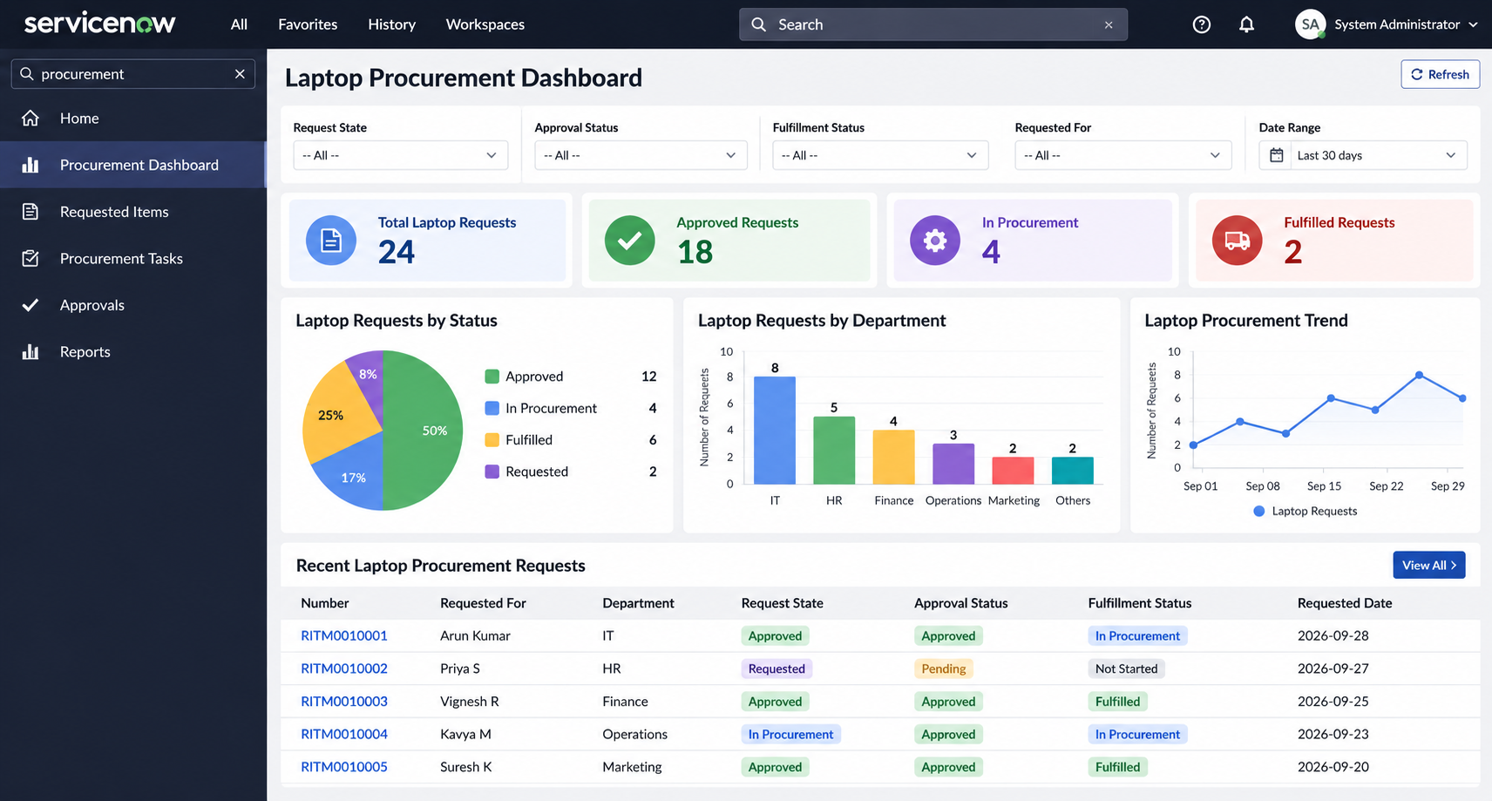  No of Visualizations / Graphs - 3
6. | Report Design | 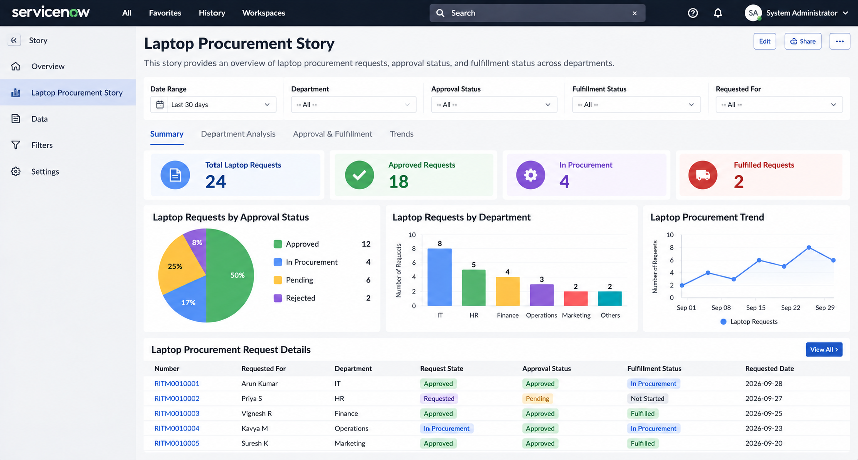  No of Visualizations / Graphs - 3

